Your data protection rights

Your right to be informed that we are using your personal data
This leaflet explains what we’re collecting and why we’re using your information. We have also put a “Privacy Notice” on our website to explain this in a little more detail.

Your right of Access: How to get copies of your data
You can ask us for copies of your health information. We have a form which you can use, and we will ask you for some kind of identification documentation so we can be sure that we send the information to the right person.

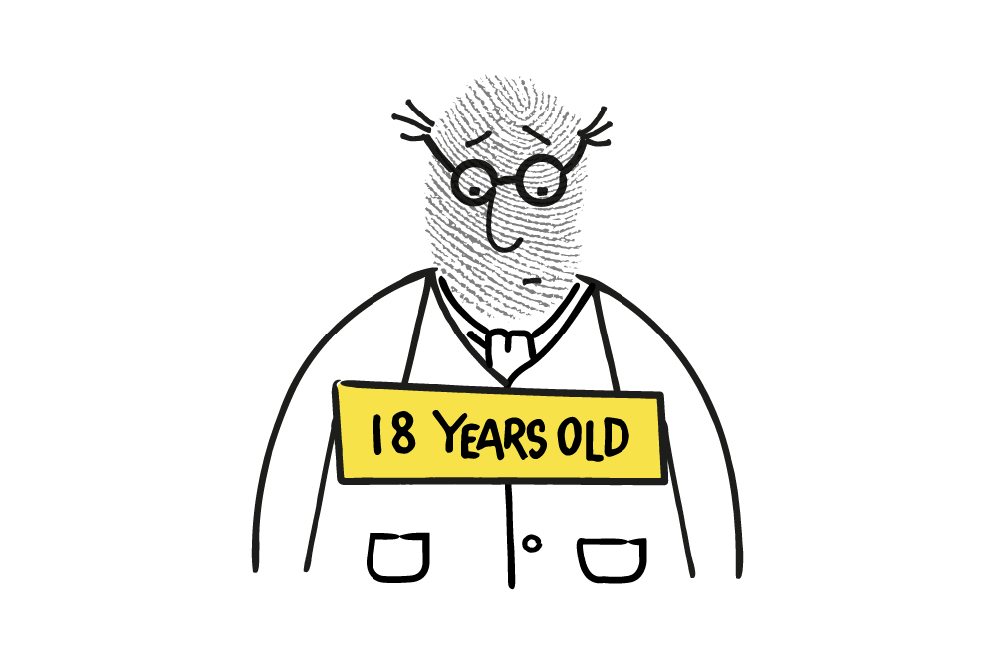
Your right to have your data corrected
If you think the information we hold about you is not correct, you can ask us to amend it or delete it. We will amend your information if we can; but there may be times when this is not possible. If we can’t, we will explain why. Also, sometimes we might need to keep the original information if it is an opinion, or if we need to be able to compare the mistaken information with the more accurate information. We will tell you if we do need to keep both.

Your right to have your data deleted
We keep your information because we need it in order to provide safe health care for you. There are times when you can ask us to delete the information we hold about you, but it may not be possible for us to do so. If we can’t, we’ll explain why.

Your right to limit how we use your data
We use your information for your health care but also for a number of other reasons (some of which we have described on the front of this leaflet). We hope that you will be happy for your data to be used this way, but you can ask us to limit the use of your information. If you do, please contact us to discuss this further so we can understand and answer your concerns.

Your right to data portability
This right allows you to ask for transfer of your personal data from one IT system to another. However it only applies when we have asked for your consent to use personal data that you have given us and we then process that information automatically (without human input). This isn’t how we normally use your information so this right won’t usually apply. The ICO has further guidance that you might find helpful:
https://ico.org.uk/your-data-matters/

Your right to object to the use of your data
We use your information to provide your health care. If we use it for more than that, we would normally ask your permission first. If you aren’t happy with what we are doing with your information you can ask us to stop. We will do as you ask unless there are other reasons why we need to continue; but we will always discuss this with you first.

Your right to raise a concern
We hope that you will be happy with how we manage your information, but if you do have a concern please contact the Trust using the details below.

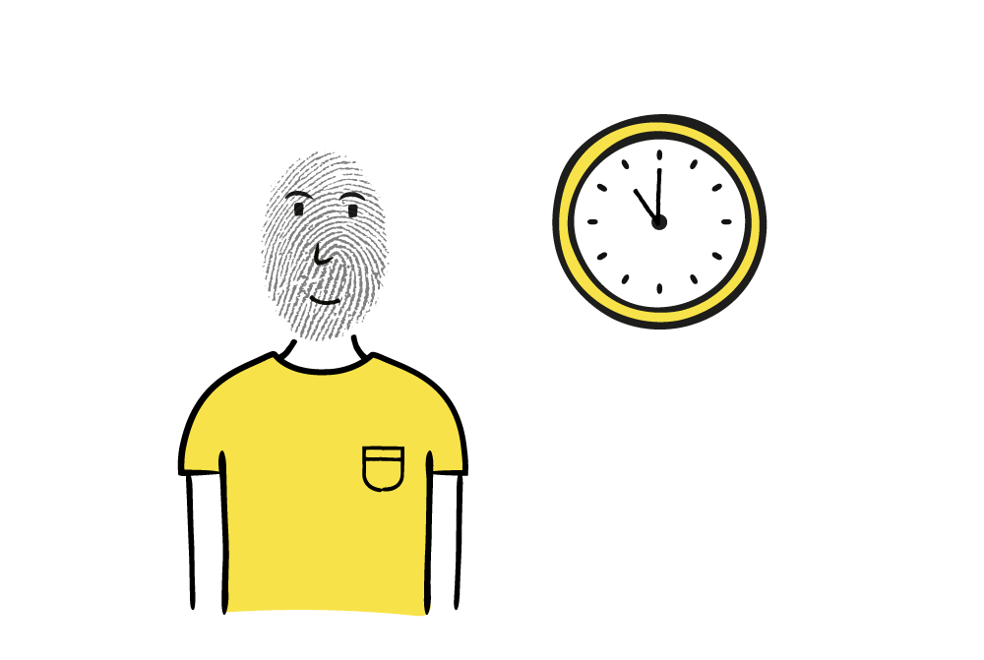
Time limits to responding to data protection rights requests

We should provide you with a reply within 30 days. We’ll let you know if we are likely to take longer, and we will explain any delay to you.

Contact details:

Upper Eden Medical Practice
Silver Street
Kirkby Stephen
Cumbria
CA17 4RB

Tel: 017683 71369

Website: www.upperedenmedicalpractice.co.uk

Facebook: www.facebook.com/UpperEdenMedicalPractice

What is the purpose of the General Data Protection Regulation (GDPR)?

GDPR governs what our organisation does with your personal data and gives you certain rights in relation to your personal information.

Why we collect information about you
Your doctor and other health professionals caring for you keep records about your health and any treatment and care you receive from the National Health Service. These help ensure that you receive the best possible care from us. They may be written down (manual records) or held on a computer.

The records may include:
- Basic details about you, such as name, address, date of birth, NHS Number and next of kin
- Contacts we have had with you, such as clinic visits
- Notes and reports about your health and any treatment and care you need
- Details and records about the treatment and care you receive
- Results of investigations, such as X-rays and laboratory tests
- Information from other health professionals, relatives or those who care for you and know you well.

How your records are used to help you:

We use your information to help provide you with the health care you need. Your records are used to:
- Ensure that your doctor, nurse or any other healthcare professionals involved in your care have accurate and up-to-date information to assess your health and decide what care you need when you visit in future.
- Allow us to contact you for health checks (for example cervical smears, breast screening or other preventative treatment)
- Ensure full information is available should you see another doctor, or be referred to another part of the NHS or other organisation involved in your care
- Ensure there is a good basis for assessing the type and quality of care you have received
- Allow your concerns to be properly investigated if you need to complain

THE UPPER EDEN MEDICAL PRACTICE

GDPR - What does This mean for me?

EXPLAINING YOUR DATA PROTECTION AND CONFIDENTIALITY RIGHTS

